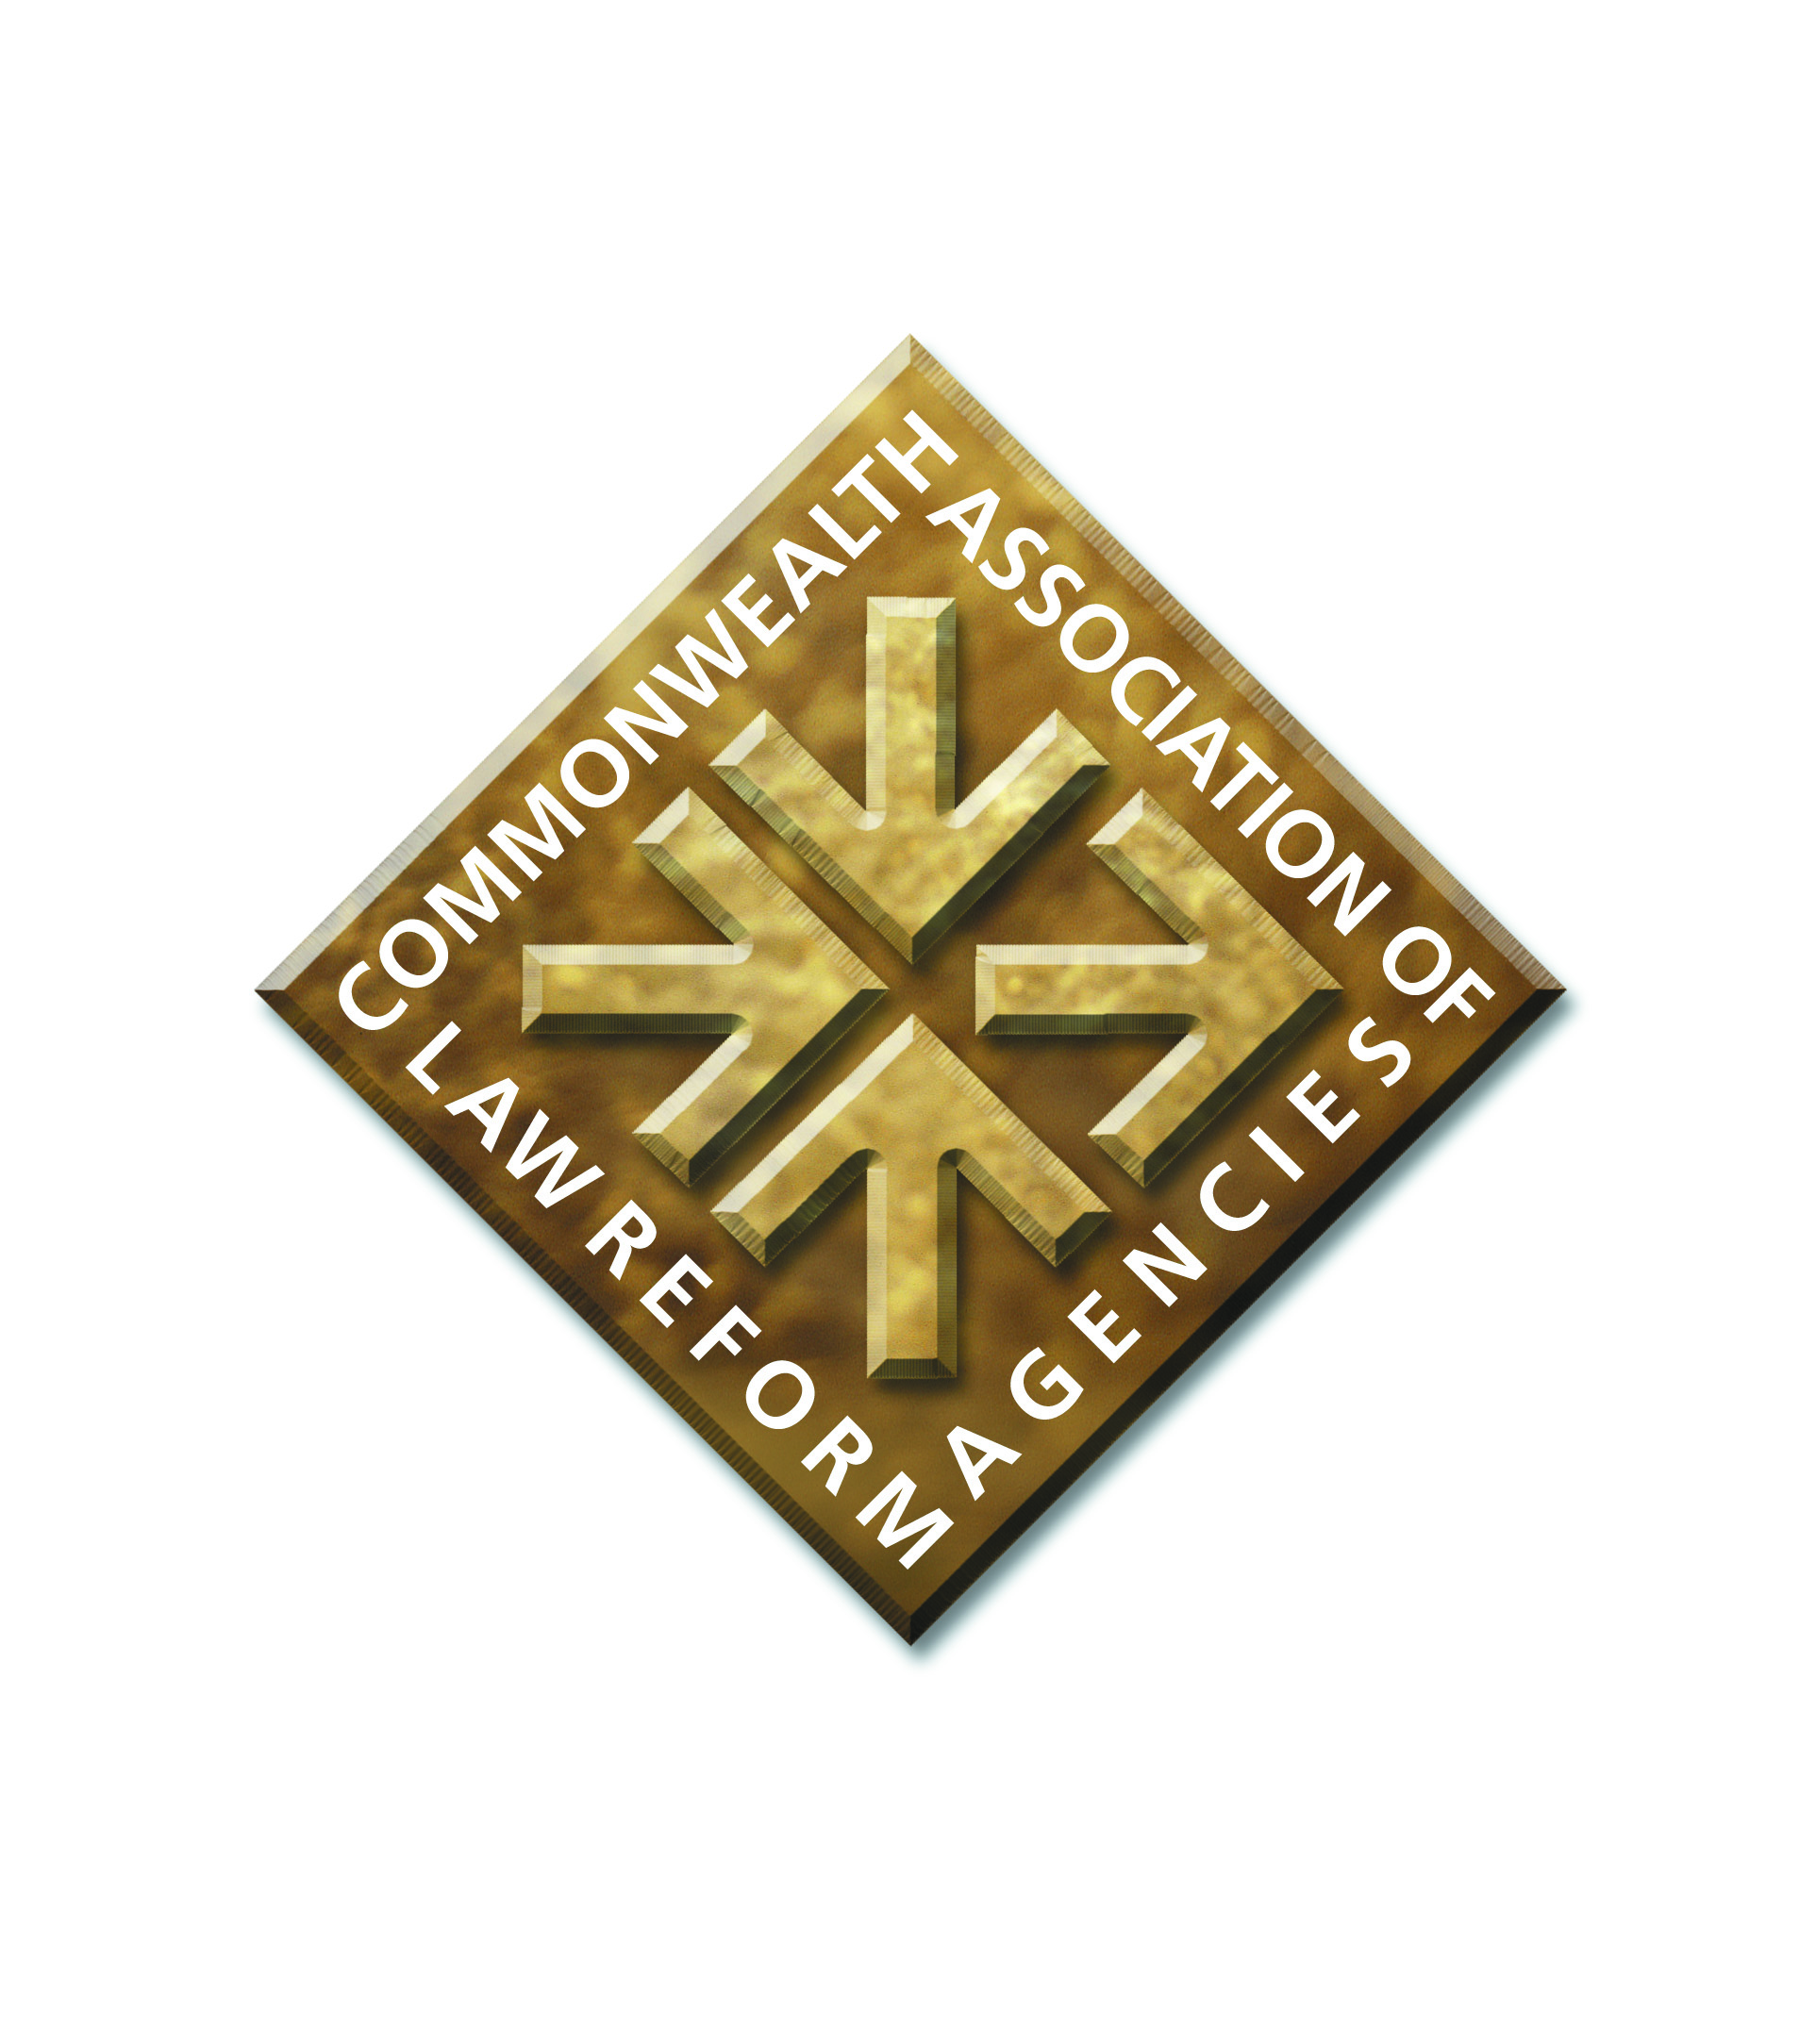

**Minutes**

**of the**

**General Meeting of the Commonwealth Association of Law Reform Agencies**

**held in Goa, India on 4 March 2023**

*General Secretary’s Report*

1. The Meeting considered the terms of the Report submitted by the Interim General Secretary dated March 2023. Members noted the position in relation to the post of General Secretary.
2. A proposal was made that the Interim General Secretary, Malcolm McMillan, be appointed as the General Secretary. Members approved the proposal.
3. The Meeting noted that CALRAs had sought and obtained continued accreditation with the Commonwealth as a partner organisation in the autumn of 2022.
4. Members noted the continued representation of CALRAs, and the promotion of law reform agencies and of the value of law reform, by the General Secretary; in particular at the Meeting of Commonwealth Law Ministers in November 2022; and the continued liaison with other Commonwealth partner organisations such as the Commonwealth Secretariat, the Commonwealth Lawyers’ Association and the Commonwealth Association of Legislative Counsel.

*Treasurer’s Report*

1. The Meeting considered and noted the Report by the Treasurer comprising a Balance Sheet as at 31 December 2022 and a note of income to 1 March 2023.
2. It was noted that the opportunity had been taken to change the invoicing system for CALRAs fees and address the issue of outstanding fees. CALRAs had contacted all members about the position.
3. No other business was raised.