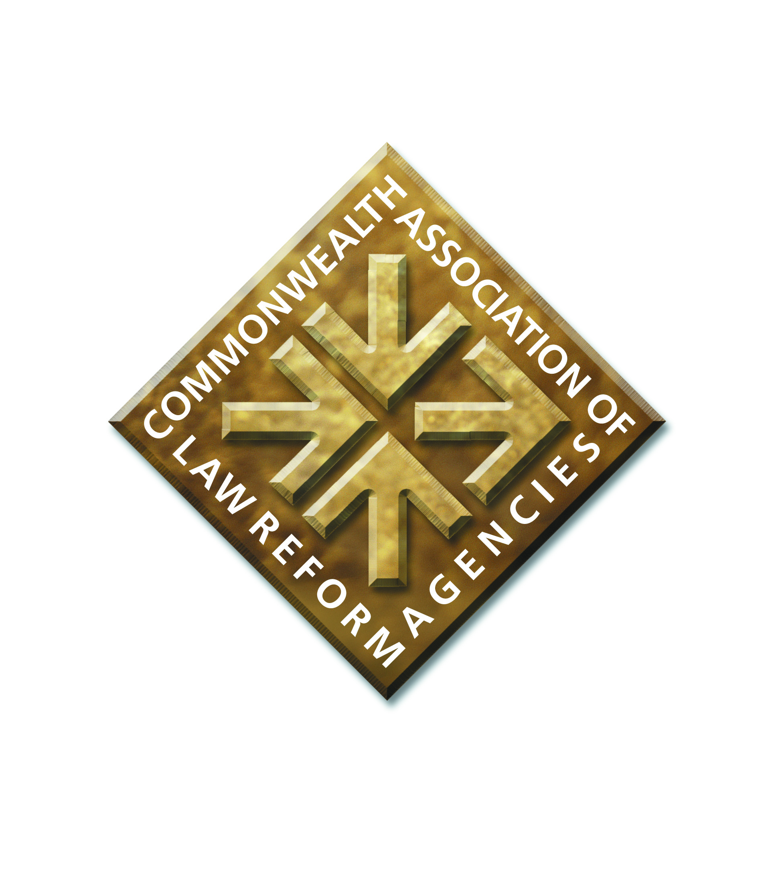

**GENERAL MEETING**

**of the**

**COMMONWEALTH ASSOCIATION OF LAW REFORM AGENCIES**

**at St Julian’s, Malta on 5 April 2025**

**REPORT by the GENERAL SECRETARY**

**Previous CALRAs Conference and General Meeting**

1. This report covers the activities of CALRAs since the last CALRAs Conference.

2. The last Conference and General Meeting of CALRAs was held in Goa, India, on 4 March 2023. The Conference and General Meeting were the first CALRAs events held since 2019, due to the covid outbreak and the period of lockdown.

3. The CALRAs Conferences are usually held on a biennial basis. They provide a valuable opportunity for law reformers to meet in person, and share best practice and recent experiences of law reform and law reform methodology. These Conferences assist in enhancing law reform capacity on an international scale, and they encourage co-operation between law reform agencies.

**CALRAs website**

4. A new CALRAs website was set up and launched following the Goa Conference in 2023. At [www.calras.org](http://www.calras.org). The website is a source of information about CALRAs, who we are, our objectives and our history.

5. Presentations from the Goa Conference and from some previous CALRAs Conferences are available on the website as a resource for law reformers.

6. The website is available for further development. An example may to use the website to highlight and promote law reform events, news and publications, if CALRAs members wish to do so.

**Accreditation with the Commonwealth**

7. CALRAs has been accredited for many years as a partner organisation to the Commonwealth. As a result of accreditation, CALRAs is invited to participate in Commonwealth events, such as the biennial Meeting of Commonwealth Law

Ministers; and to liaise with the Commonwealth Secretariat in promoting law reform. The status of accreditation enables CALRAs to represent the interests of law reform and law reform agencies, and highlight the value of law reform, to Ministers.

8. In 2024, the Commonwealth issued new guidelines on accreditation with the Commonwealth, and asked partner organisations including CALRAs to apply for re-

accreditation. CALRAs applied with submissions about our aims and activities, and our finances. Accreditation was successfully achieved in June 2024.

9. As part of continued accreditation, a report on CALRAs activities and finances is submitted each year to the Commonwealth Secretariat.

**New members**

10. Since the last Conference we have seen a growth in membership, along with renewed contact with some existing members. We have had further recent enquiries as to membership.

11. We were delighted to welcome new members to CALRAs: the Seychelles Law Commission; the Law Reform Commission of Ireland; the Queensland Law Reform Commission; the Attorney General’s Chambers of Eswatini, who are establishing a new law reform agency; and an individual member, former Acting Chief Executive of the Scottish Law Commission, Charles Garland.

12. We also have 2 further applications made recently to join CALRAs, and these are awaiting Executive Committee approval: from the Cayman Islands Law Reform Commission and the Attorney General’s Chambers of Zanzibar.

**Engagement with the Commonwealth and Ministers**

13. CALRAs represents the interests of law reform agencies and promotes the value of law reform generally, and in particular within the Commonwealth and at Meetings of Commonwealth Law Ministers. These Meetings are held on a biennial basis. CALRAs has been represented at every Commonwealth Law Ministers’ Meeting since 2005, and at many Meeting of Ministers of Small States.

14. We submit a written report about CALRAs to Meetings of Ministers, and make an oral report to the Meeting. The Meetings are a valuable opportunity to engage with Ministers, Law Officers and officials informally, to encourage the establishment of law reform agencies and the provision of support for existing agencies. There is also the opportunity to foster good relations with partner organisations such as the Commonwealth Secretariat, the Commonwealth Lawyers Association, and the Commonwealth Association of legislative Counsel, who are also represented at the Meetings.

15. The General Secretary represented CALRAs at the last Commonwealth Law Ministers Meeting in Zanzibar in early 2024.

**Liaison with other organisations**

16. CALRAs has continued to liaise with and build relationships with other justice sector organisations in the Commonwealth. These include the Commonwealth Secretariat; the Commonwealth Lawyers Association (the CLA); and the Commonwealth Association of Legislative Counsel (CALC).

17. Examples of CALRAs working with the Commonwealth Secretariat are provided elsewhere in this Report. The CLA have been supportive of CALRAs, in particular with the practical aspects of arranging our Conferences. CALRAs assistance has been given to the CLA, in preparing sessions on law reform for their biennial Commonwealth Law Conferences. CALC office -bearers have contributed to recent CALRAs Conferences.

**Law reform Guidance and training**

18. The Commonwealth Secretariat/CALRAs joint publication: Changing the Law, a Practical Guide to Law Reform, continues to be a valuable resource for training and advice about law reform and law reform processes. The Guide is used as a resource by government officials, law reform agencies and others. Positive feedback about the

Guide is regularly received. The Guide is available on the CALRAs website, and hard copies can be purchased from the Commonwealth Secretariat.

19. CALRAs regularly contributes to or facilitates training programmes in law reform and law reform methodology. The aim is to assist in building law reform capacity in law reform agencies, often for new or developing agencies but also for new staff and Commissioners in existing agencies.

20. In 2024 the Commonwealth Secretariat organised a law reform programme in Namibia for law reformers and legislative drafters. The course was delivered by the General Secretary as a law reform consultant and Matthew Jolley, Head of Legal, Law Commission for England and Wales.

**Administrative support for CALRAs**

21. Following the Goa CALRAs Conference we sought potential sources of assistance for CALRAs to support our work. We were looking primarily for some administrative support especially for CALRAs finance functions. CALRAs received an offer from the Law Commission of England and Wales of administrative assistance, subject to the priorities of the Commission; and an offer in principle of some administrative assistance from the Scottish Law Commission. The CALRAs Executive Committee accepted these offers.

22. CALRAs is very grateful indeed to the Law Commission of England and Wales for their support for CALRAs generally and for their assistance in preparing for this Conference. In particular to Matthew Jolley, Head of Legal, and Courteney Rose, International Manager; and to Dhruv Singhai, Research Assistant, for assisting with the CALRAs finance and invoicing functions. Matthew Jolley has been included in Executive Committee exchanges, as an observer, so he can represent the interests of the Law Commission as regards any resources provided to support CALRAs.

**Legal status of CALRAs**

23. CALRAs has a written Constitution. It is available on the CALRAs website. As regards legal status, on one view CALRAs may be an unincorporated association under English law, having been established by a constitution drawn up in England and managed for many years by the founding General Secretary from his home in England. The position however is far from clear.

24. There has been interest recently in clarifying and improving the legal status of CALRAs, and thereby clarifying responsibility and accountability for CALRAs. The Executive Committee agreed in principle to a review of the legal status of CALRAs and the identification of options for reform. Options may include becoming a charitable organisation, or incorporating in some other way; potentially in England or Scotland, and the opening of a CALRAs bank account in the UK to facilitate the financing of CALRAs business.

25. We had hoped to obtain expert advice on the matter, on a pro bono basis, and prepare a note of options and a recommendation to put to the Executive Committee for consideration. We have not found any source of pro bono advice.

26. I propose that making progress on this issue is a priority for CALRAs over the next year.

**Engagement with members and general enquiries**

27. The General Secretary and Treasurer provide a point of contact with CALRAs for members and others interested in law reform. There is a regular flow of email enquiries from members, and from enquirers about CALRAs, and about law reform and law reform agencies.

**Malcolm McMillan**

**General Secretary**

**CALRAs**

**31 March 2025**