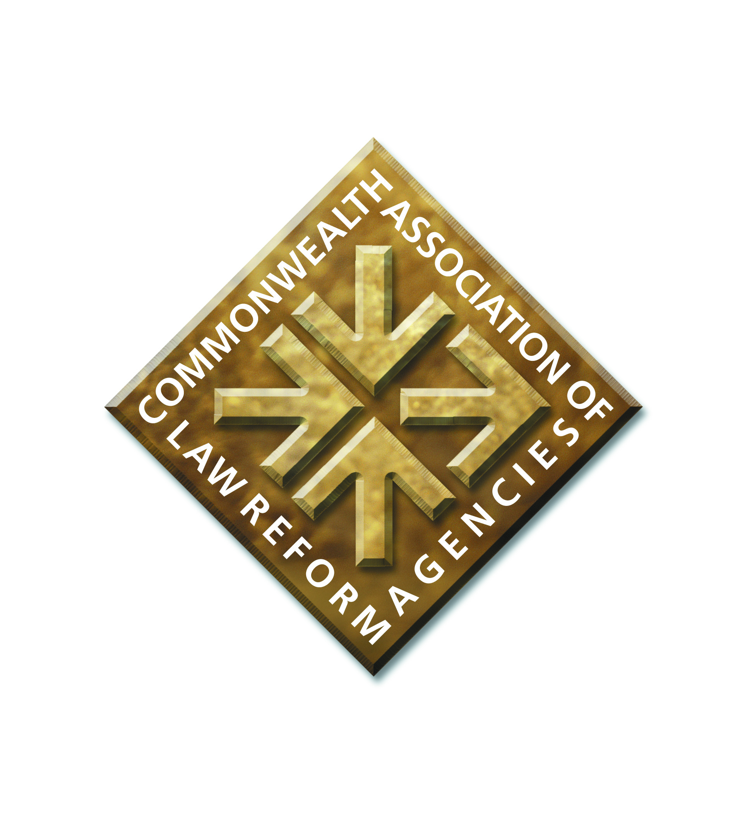

**CALRAs CONFERENCE 2025**

**Hilton Hotel, St. Julian’s, Malta**

**4 and 5 April 2025**

**OPENING ADDRESS**

Good morning everyone. A very warm welcome to this CALRAs Conference.

To introduce myself: I am Malcolm McMillan, the General Secretary of CALRAs. I was for many years the Chief Executive of the Scottish Law Commission. And earlier in my career I worked as a researcher and project manager at the Scottish Commission.

I know some of you have had to clear hurdles to get here, through the processes of getting visas and authorisations, and some have travelled far to get here. Congratulations on getting here.

This is the 10th CALRAs biennial conference. CALRAs was established in 2003/4. Previous conferences have been held since 2005 in England, Kenya, Hong Kong, India, Australia, Scotland, Zambia, and after skipping a conference in 2021 due to the covid restrictions, in India again in 2023, in Goa.

A CALRAs conference is a unique opportunity to gather together law reformers from across the world. We are a Commonwealth organisation, but we also extend our reach beyond into the international world of law reform. We are a unique band of folk. The aim of CALRAs, and of this conference, is to enable law reformers to share our experiences

of law reform with each other. Our successes and challenges alike. We can be candid with each, in a safe and understanding environment. We can thereby encourage each other and learn from each other. And so build capacity for successful law reform in law reform agencies across the world. This is a vital task.

We should keep in mind the wider context of our work – namely that law reform and law reform agencies play a significant role in maintaining and promoting the rule of law, and good governance. Our contribution assists our jurisdictions in working towards the Commonwealth values and principles set out in the Commonwealth Charter, and the UN 2030 Development Agenda and the UN Sustainable Development Goals, in particular Sustainable Development Goal 16.

Tomorrow afternoon we have the opportunity to reflect on what we can do to strengthen CALRAs and what more we as CALRAs can do to promote law reform. We have our General Meeting, to note the work CALRAs is doing and to renew our Executive Committee with a fresh and talented team. We have a session to consider the future activities of CALRAs. The key point is that CALRAs is a membership organisation. We do not have paid staff or advisers, or an office base; we do not receive funding from any source other than modest membership fees. The cohesion of CALRAs is based on voluntary support – the Treasurer, the General Secretary. With some administrative support from the Law Commission of England and Wales, and the support of the Executive Committee. So the question to members for that session is: what can you offer to do to support or extend CALRAs activities in the future? Please feel free to reflect during the Conference and to speak to me about any ideas you have to offer.

I have messages of support for CALRAs and this conference and greetings from stalwarts of law reform who are not able to be here for various reasons. From Lady Ann Paton, the Chair of the Scottish Law Commission; Professor Jummai Audi,

President of the Law Commission of Nigeria; I recall that Professor Audi from Nigeria set a bar for chair of CALRAs sessions, when chairing a session at our conference in Goa - she sang us a song….. We have greetings from Michael Sayers OBE, co-founder and long- serving General Secretary of CALRAs, whose letter of encouragement to us was shared with you by email; and we have a message of support from Shauna Van Praag, President of the recently established Law Commission of Canada, who wishes to engage with CALRAs and our conferences in the future.

There is in fact a contribution to this Conference from Canada. I raise an interesting question about the role of law reformers, a question asked by Shauna Van Praag at a seminar last year. Law reformers: what are we – plumbers, problem solvers, or poets? That is our ice-breaker for this conference! Speak to someone you do not know yet, over coffee – ask them for their reflections on the question. Perhaps we can give our individual answers as the conference progresses. The answers may inform the dress code for the next CALRAs conference?

My own reflection on the question - I think that as well as plumbers and problem solvers and poets for our legal systems, we also sometimes need visionaries, or prophets, amongst us in the world of law reform. People who look ahead and see new challenges coming down the line for society, and who call for a fair and just legal framework to address the challenges. Challenges arising from new developments in the world. Challenges that might point to the need for a law reform project.

I suggest that Malta offers us the inspiration to be visionary. In the form of the prophetic work of Malta’s Permanent Representative to the UN in 1967, Arvid Parvo. He became known as the Father of UNCLOS, the new Law of the Sea. This takes me back to a fascinating study of the international law of the sea when I was a student in Edinburgh and recognising him today brings a sense of fulfilment. Arvid Pardo made a stirring and comprehensive speech to the UN General Assembly on 1 November 1967, over 3 hours long. A visionary, he anticipated the technological developments that would enable deep sea mining; and the likelihood that those who would benefit would be the richer nations with the advanced technologies. He called for international regulation to ensure peace at sea, prevent further pollution and protect the oceans’ resources; proposing that the world’s oceans beyond national jurisdiction constitute part of the common heritage of mankind and that some of the wealth created from the sea by mining be used for a fund to help close the gap between rich and poor nations. This speech started a process, culminating in UNCLOS, the United Nations Convention on the Law of the Sea, which opened for signature in 1982.

What was eventually in the Convention did not reflect all that Arvid Pardo had proposed. Nevertheless the proposals and years of work did result in the Convention.

The issue of implementation of proposals to reform the law, and the time taken to implement, is close to the heart of CALRAs members. A topic perhaps for our next conference.

With that inspiration from Malta, we have the opportunity later in the conference to reflect on new challenges to society coming our way, new developments in artificial intelligence, brings things to the law and justice system that we have to struggle with, and perhaps calling for the introduction of new legal frameworks.

Some housekeeping points before we proceed.

When asking a question or making a contribution – we have roving microphones here to use; please introduce yourself - tell us your name and which organisation you are from.

Following each presentation I suggest that we show our appreciation for the speaker, for their contribution and the insights shared, by a round of applause.

Our coffee breaks and lunches during the Conference will be available immediately outside this meeting room.

At the end of today’s sessions, you are invited to join us in the Bar for a drink.

Following the Minister’s speech, we will immediately go into the first session on Milestones in Law Reform. So after the Minister has spoken could the Chair and speakers for the first session please come up to the table and begin.

I now welcome Dr Jonathan Attard, the Minister for Justice and Reform of the Construction Sector of Malta, to this conference. It is always a pleasure, and makes us feel at home when we have a welcome from the host jurisdiction. We appreciate this. The Minister will now address us.

Malcolm McMillan

General Secretary

CALRAs